Going South

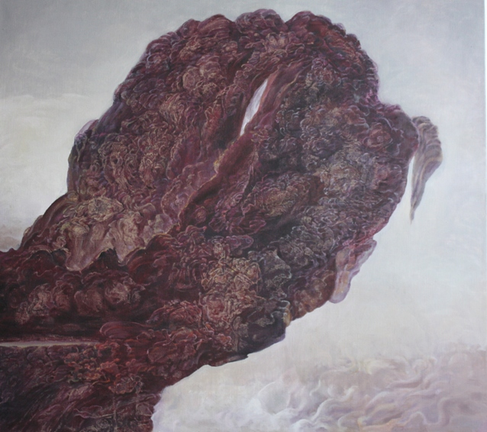
Taking Risks 2014.
My recent, Going South exhibition, in Somerset House, London in June 2015 was the concluding event to my Leverhulme artist’s residency in the Department of War Studies at King’s College London in 2014/2015. Going South is an ongoing painting project which is predicated on a set of journeys I have made and will make to the southern ‘edge of the skirt of the world’. This metaphor marks a set of engagements with the coastal and mountainous landscapes of New Zealand, Australia, South Africa, Argentina and Chile and a subversive sensibility that troubles the patriarchal assumptions of the tradition of sublime landscape painting. In so doing my painting practice registers the impact of an unnamed and repressed, but sexuate discourse, through which I have struggled to perform myself as an improper subject of the landscape, looking back at those histories of painting in which female agency and desire have no place, and forwards toward a time when they do.
I will complete this project in 2016 and am looking to exhibit a selection of paintings from this body of work in 2017 or 2018. My website www.lolafrost.net contains more information, more images, including three catalogues: Coming Alive 2013; Taking Risks 2014 & Going South 2015 and my CV. If you are interested in this project, please contact me at lola.frost@btinternet.com

Some thoughts on the political relevance of this body of work:
“The phrase ‘going south’ has at time been colloquially figured, in the North, as going down under, down on, cashing out, toward a worse position.... off the map”.
This conceptual hook, derived from a definition of the term ‘going south’ in the Oxford English Dictionary, framed my Going South exhibition of paintings in June 2015. As a political intervention, I understand that this Going South project disrupts those hierarchies which privilege the north over the south; (financial) success over (cognitive) failure; or those discourses which endorse properly regulated bodies over supposedly improper flows of desire, in particular those bodies and desires of women; or which sustain the power of concepts over the ambiguities and unruliness of psychic life and aesthetic experience. In so doing this practice not only challenges a logocentric patriarchal status quo, but also invites a subversive form of agency for those subjects, who like myself, are interested in resisting the regulations of what Irigaray calls ‘an economy of sameness’, whose norms and repressions inform much of our post 9/11 and globalising world.

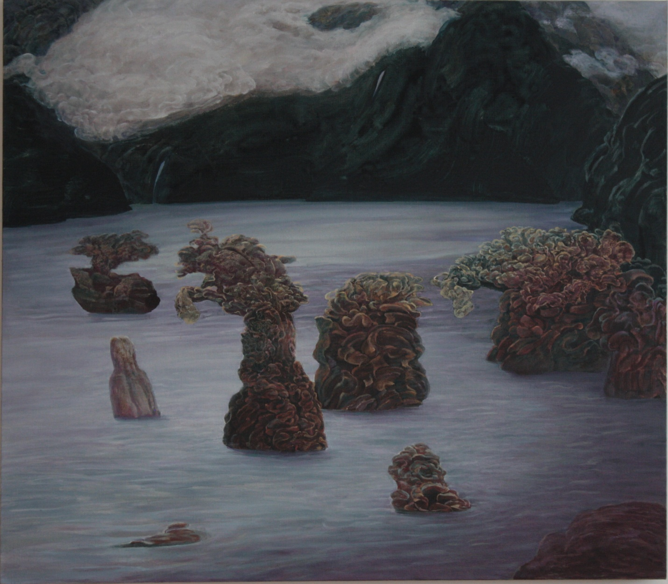
At the edge of the skirt of the world 2014
For example, the painting titled At the Edge of the Skirt of the World, Oil on Linen. 104 x 130cm. 2014, is something of an ‘opera buffa’, where these lady-like creatures (informed by photographs of The Apostles, rocks off the coast of Victoria on the south coast of Australia), which in hats and skirts are assembled in waters of a sublime lake and streaming mountains (Milford Sound in New Zealand). These feminine skirts are a reference to the idea behind this overall project: namely to chart an actual journey around ‘the edge of the skirt of the world’, where I have travelled to the tips of New Zealand, Australia, South Africa, and will continue to the mountains and coasts of Argentina and Chile. ‘Going south’ in this painting registers something of an absurd gaiety about and solidarity with improper psycho-sexual and feminine energies, all of which are folded into this metaphorical southern terrain and an itinerant global circuit.

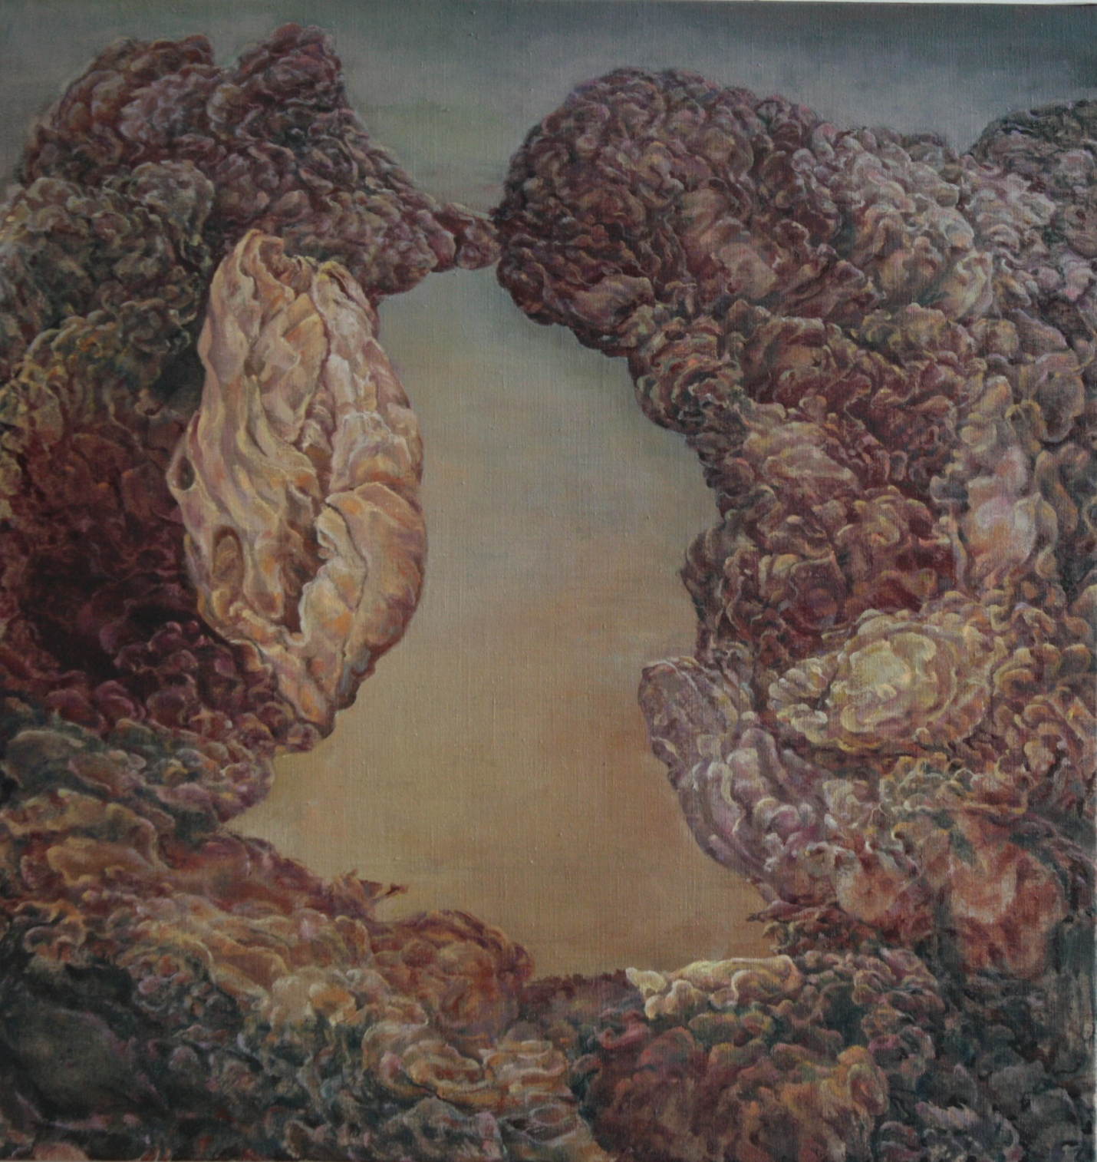
The Opening 2015
The Opening, Oil on Linen. 73 x 77cm. 2015, was conceived whilst walking south, on the Tzitzikama coast in the Western Cape in South Africa. It too is a register of the impropriety of a southern, and in this case, sexual orientation, insofar as this opening simultaneously seems to open and to close, like a little sexual frisson, gone when you look too hard, or try to conceptualise it. It is the infection of ‘form’ with ‘energy drive’, I suggest, which in concert, produces a perceptually coherent set of motifs and forms, and simultaneously releases an unspeakable and perpetually enfolding energy, that produces the signature style of this painting practice. This style of painting is thus itself a form of ‘going south’, releasing a libidinal or somatic energy that has often been subjugated into social regulation wherever we come from and what ever gender we might be identified through.

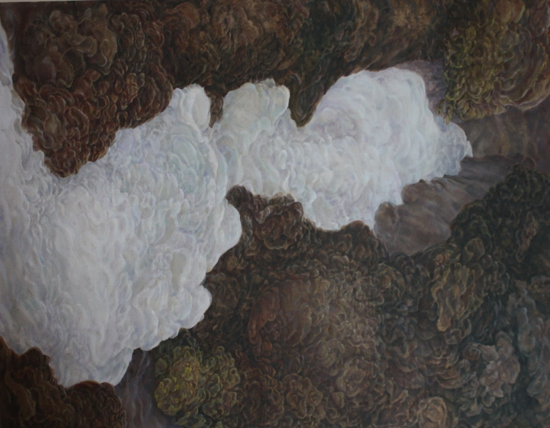
Streaming 2014
Streaming, Oil on Linen. 117 x 150cm. 2014, like all of these paintings, finds its inspiration in experiences of events in the landscape, which I photograph and reconfigure as collages in my studio. These collages are the beginning of a process in which I traverse and attune to my drives, memories, unconscious energies, to this ‘chiasmic’ or enfolding signature style, and in so doing opening up psychic portals and producing ‘thing-like’ objects and uncanny interior/exterior spaces that have a life of their own.
Recognisable perhaps as a gushing stream, this large orifice literally pours forth its bodily fluids. This body of work might thus be conceived of as a libidinal machine, one which detaches from, and critiques, its original territory, and I have in mind the western tradition of sublime landscape painting and all those discourses in which female agency and desire are controlled and repressed by patriarchal interests.

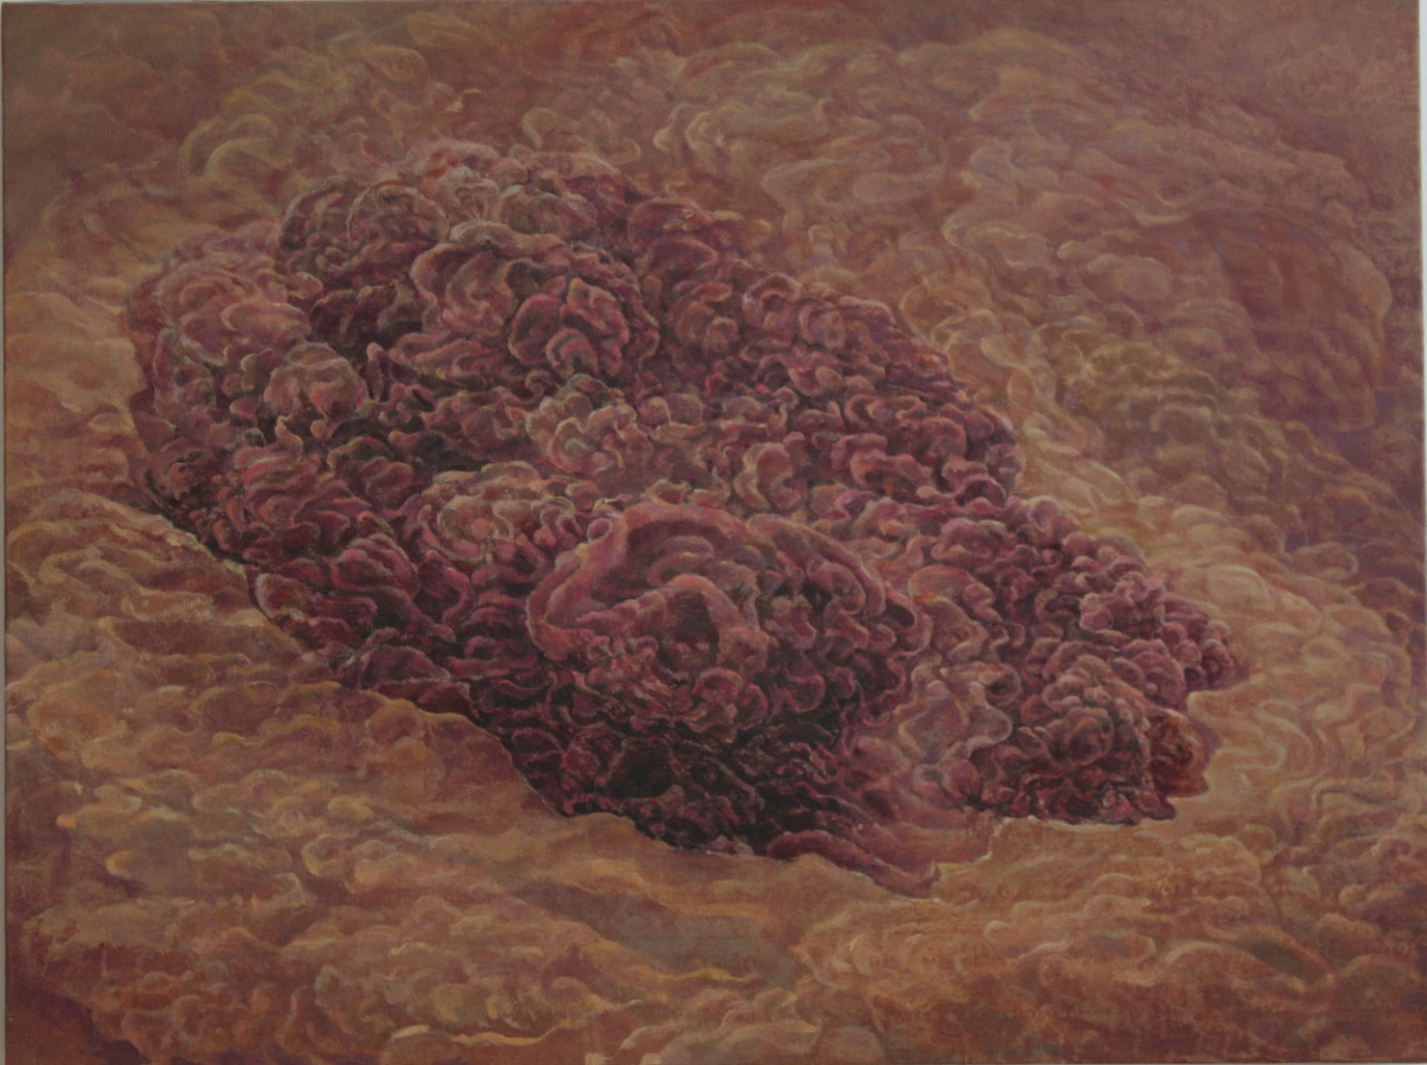
Wild being 2015
The energies released by such enfolding and somatic activity can be unsettling. Wild Being, Oil on Linen. 101 x 70 cm. 2015, verges on the monstrous. Also derived from a walk along the alpine valley at the base of the glacier flowing off Mount Cook, the highest peak on South Island, New Zealand, this ‘eruption’ spews forth from its ground as a hot emanation. The distinction between figure and ground is only registered in the slight indentation or crease where these two zones both connect and separate. Indeed the whole painting suggests an infinity of enfoldings, unrestrained by time and place; a mad, improper and perpetual becoming.
Another way of saying this is that such seemingly monstrous repetition and difference, produces another version of the experience of the sublime, insofar as cognition and imagination collide. This might be called a ‘visceral sublime’, insofar as these landscape paintings seem to morph into internal viscera or body parts, often associated with brains or coral. In so doing, I understand that this somatic practice deconstructs aspects of the tradition of sublime landscape painting, for example the hierarchically arranged distinction between self and nature. For in Wild Being the disaggregated viewer cannot stabilise his or her experience with a closing concept even as he or she might imagine a multiplicity of becomings and enfoldings that also overrun the distinctions between ‘the self’ and ‘the natural world’.

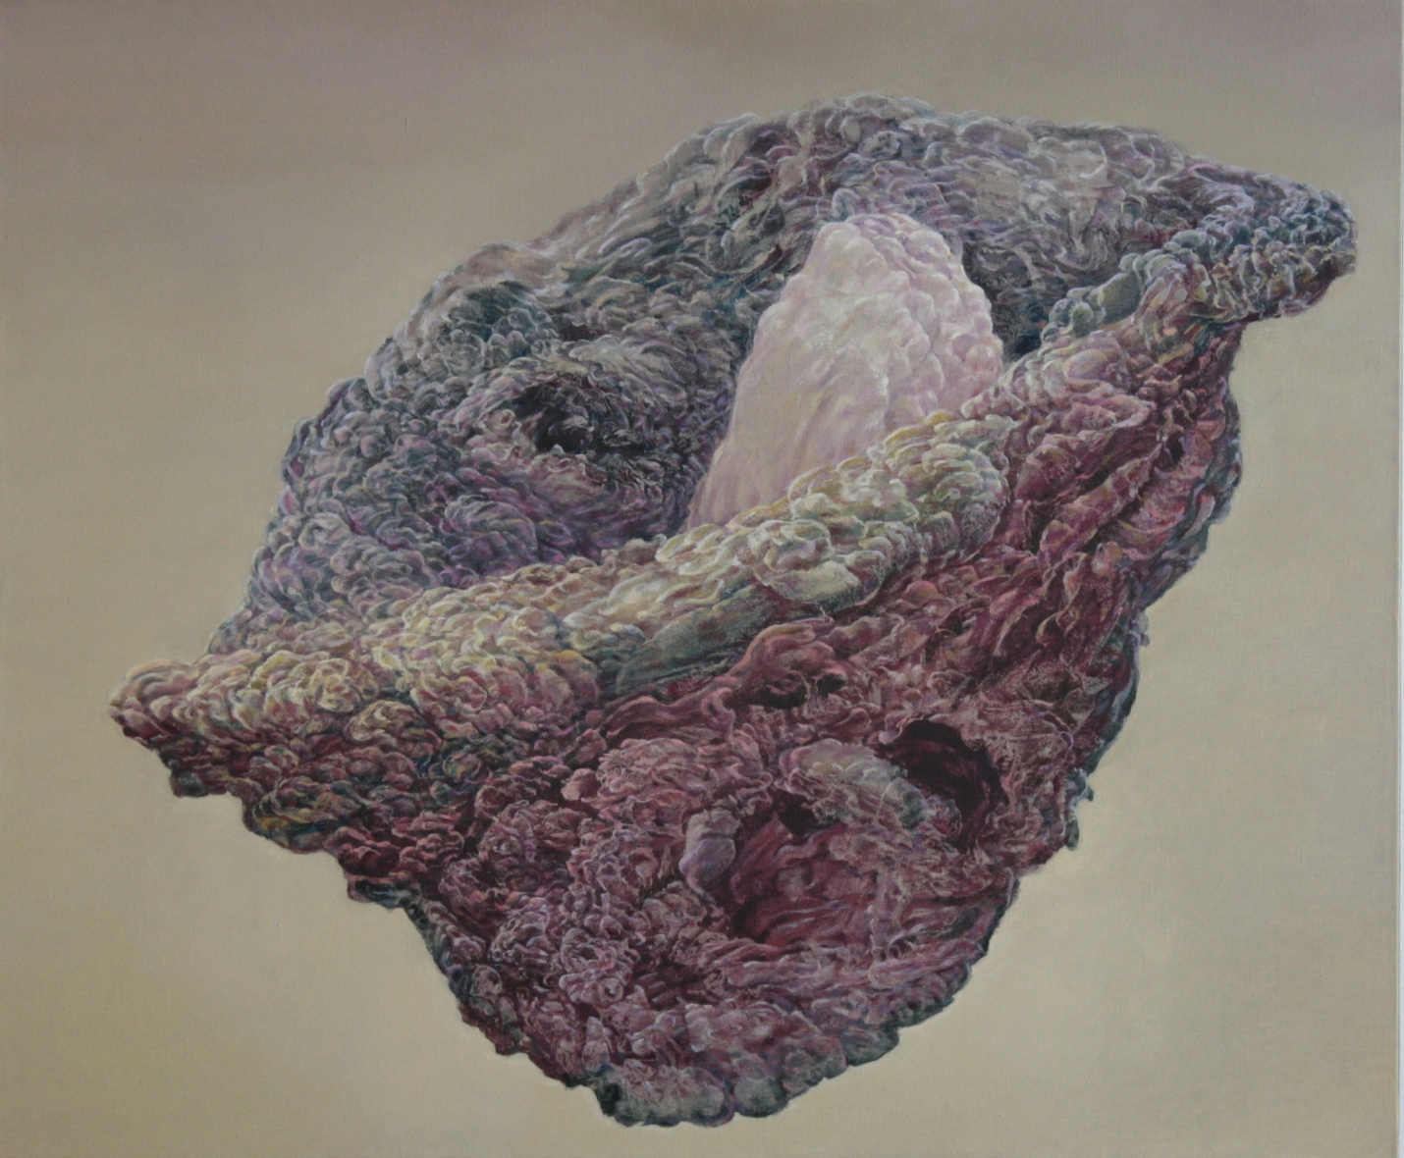
Going South 2015
Going south in these paintings then seems to be a productive, if risky and disorienting destination. This project’s namesake painting titled, Going South, Oil on Linen. 94 x 78cm. 2015, derived from photographs of the small mountain at Rooi Els, which marks the south eastern tip of False Bay and a range of mountains near Ceres in the Western Cape, South Africa, proposes a different relation between the viewing self and those discourses which sustain the patriarchal and logocentric status quo. This full vessel, radiantly and serenely poised, destined to go ‘off the map’, could be read as an invitation to take up that which improper and unspeakable, by going into those subversive, somatic and risky possibilities that are opened up when we ‘go south’.
It remains to be seen how the mountainous landscapes of Chile and Argentina impact on the completion of this project.

Lola Frost, February 2016.

